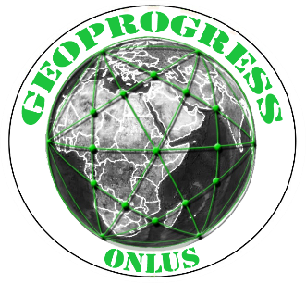
GeoProgress, Onlus
c/c Università del Piemonte O.
Via Perrone 18 - 28100 Novara, Italy
Tel. cell. +393351243112 www.geoprogress.eu
Cod. Fiscale 94063920030

GeoProgress Global Forum (GGF) 2020-’21 on:

WATER AND SOIL CONSERVATION

INNOVATIONS GEOGRAPHY AND GOVERNANCE MODELS

Water and soil are key resources for human life. Consequently, their conservation is essential to guarantee a future existence to human beings. This vital issue depends largely on soil erosion reduction techniques, on water saving and on the agronomic technologies we use, obviously avoiding to continue destroying forests and grasslands. It also depends on farming economic organization, land tenure systems, markets regulations, food distribution, national and international policies and legislation, geopolitics. Great importance has the growth of scientific knowledge and technical innovations, as well of the social factors limiting their diffusion. Geography of soil and water, their conservation methods and policies, in dynamic terms, through a continuous monitoring process, are also essential to direct policies and plan actions at various scales.

The GGF on Soil and Water Conservation is promoted by Geoprogress, an Italian no-profit researchers’ association, and will cover issues on Earth Sciences and Engineering, Geography, Management and Economics, International Law and Political Sciences. Researchers in these different disciplines are invited to submit papers and participate in the academic exchange.

CALL FOR PAPERS
Geoprogress is soliciting state-of-the-art research papers, original and quantitative studies dealing with any technique of soil and water conservation, studies for the identification of the best practices of solving problems (scientific, technical, managerial, political) of conservation, distribution and use. Studies done under any type of climatic (arid, Mediterranean, temperate, tropical and cold) and topographic conditions, land use and management practices, are welcome, particularly manuscripts where conservation policies are evaluated. The multiple areas of interest inter alia include:
- Natural and social processes of soil and water degradation;
- Soil and water conservation technologies and Management approaches;

- Political economy of soil and water conservation;
- Geography of soil and water uses and conservation methods;
- Urbanization models/ Soil and water conservation;
- Information and analysis methods on soil and water resources and issues;

- Conservation Agriculture;
- Conservation/ Farm to fork;
- Soil conservation/ Land use/ Land tenure systems;
- Conservation/ Land use legislation;
- Soil conservation/ Land grabbing;

- Watershed Ecology and Management;
- Water use conflicts;
- Legal problems of inland water use;
- Legal problems of international freshwater use;
- Water distribution - technical and social issues.

Abstract and paper submission information

Title and Abstract (about 100 words) and, later on, the whole Paper should be sent to info@geoprogress.eu, by the following deadlines:

a) October 30, 2020 for the abstract of a manuscript proposal from authors who intend to participate in the Conference.

b) December 15, 2020 for the complete manuscript, proposed by the above authors, and for a new manuscript proposed for publication by other authors.

The Authors of the abstracts will have the opportunity to present and discuss their papers during a conference to be held possibly by the end of 2020 or, if not possible, later on. However, regardless of the discussion at the conference, all the papers will be submitted to double peer-review; and, if accepted, papers will be published in a Special Issue of the GeoProgress Journal (by December 2020).
GeoProgress Journal is an online open access international peer reviewed journal of development studies. Research articles, review articles as well as short communications are welcome.
Submitted manuscripts should not have been published previously, nor be under consideration for publication elsewhere (except conference proceedings papers); they should be well formatted and use correct English. A guide for authors and other relevant information for submission of manuscripts is available at the GeoProgress Journal page (http://www.geoprogress.eu/geoprogress-journal-pubblicazioni/).
Please visit the page http://geoprogress.eu/edizioni-di-geoprogress/, download and use the format (Style Guidelines for Author) before submitting a manuscript.

International Conference on:
Water and Soil Conservation
Innovations geography and Governance models
Expected Date: December 2020
Place: Armeno, Lake Maggiore and Orta, or online

In the desirable and probable case that there will not be any problem to meet physically, in a conference room, researchers who have proposed a paper will have the opportunity to present and discuss it.
Apart from this possibility, the contributions will also be discussed (or exclusively, in the event that the conference will take place electronically) in thematic sessions in which a speaker, rapporteur, will summarize them, highlighting above all the divergent theses on which 3-5 invited discussants will intervene. They will also have the opportunity to attend other sessions with prior registration.
Geoprogress will disseminate the conclusions, recommendations and proposals of this scientific conference, presenting them to representatives of national and international institutions, and to the public opinion through social networks.

Registration Form and Fee
The registration form is available below while the fee have to be sent by November 1st, 2020, both by researchers who wish to submit an article for publication in the Journal and by those who are also willing to present and discuss it at the Conference.
All those wishing to attend the conference, including experts representing organizations invited, are encouraged to send their registration form to info@geoprogress.eu as soon as possible.
The registration fee is:
€ 80,00 for researcher who only submit a paper for publication in the Journal after the approval of two referees;
€ 150,00 for researchers who also attend the conference, it includes the social dinner, lunch, coffee break, organization, in addition to the publication of the papers approved by two referees.
€ 100,00 for researchers who also attend the conference, if the conference will take place online.

The fee must be paid within the due date, with Bank transfer to Geoprogress (Novara, via Perrone 18) at INTESA SAN PAOLO - Terzo Settore - Filiale 55000 Novara
c/c 16996 BIC: BCITITMM
Code IBAN: IT75R0306909606100000016996

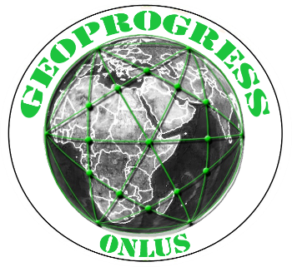
GeoProgress Global Forum on:

SOIL AND WATER CONSERVATION
Innovations Geography and Governance Models

Registration form
To be sent to: info@geoprogress.eu

Name: Surname:

Title: Occupation:

Affiliation: Country:

Address:

e-mail address: Telephone: Mobile:

Date and modality of payment of the registration fee:

I wish to speak in the debate: NO YES

Possible theme of my speech:

I wish to send a written contribution: NO YES

Title and summary of my paper:

